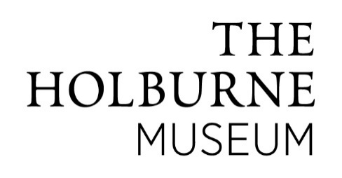

**Job Description**

**Job title:** Duty Manager

**Reports to:** Head ofVisitor Services

**Hours:** Shift work Monday to Sunday on rota system – 37.5 hrs per week

**Salary:** £23,809.50per annum.

**Context**

You will join a small and enthusiastic team at one of the country’s leading regional museums.

As well as providing first class visitor service, the post-holder will be responsible for ensuring the security of the Museum building and its site, and perform front of house duties, including supporting Volunteers, setting up and overseeing events and promoting our programme of activities and exhibitions.

The Visitor Services Team is responsible for providing a warm welcome to all of the Museum’s visitors in addition to ensuring the security of our collection. The hours covered will be 8am to 6pm daily (and 9am to 6pm on Sundays and Bank Holidays) and evenings overseeing our events. Hours will be organised on a rota system to ensure full time cover.

**Visitor Services:**

* To ensure that all visitors receive excellent care and service, and to ensure that their experience is enjoyable whilst maximising income generation across all activities for the Museum.
* To lead the volunteer front of house team in their daily tasks.
* To work at the Museum’s main reception desk or shop, to welcome visitors, sell tickets and provide information as appropriate.
* To help maintain the highest standards of visitor service and care.
* To set up facilities to support the needs of our visitors or special groups as required.
* To assist in setting up galleries and learning spaces to support our learning programme, public programme, and venue hire.
* To oversee events at the Museum and keep a photographic record for future promotion.
* To ensure the highest standards of presentation are maintained, including all areas within the museum buildings and the grounds.
* To ensure all email enquiries are dealt with in a timely manner.
* To create promotional material to an agreed specification following communications guidelines.
* To liaise with potential venue hire clients.

**Security and Health and Safety:**

* To ensure the security of the building and its contents.
* To undertake procedures for the secure opening up and locking down of the Museum building and site.
* To ensure that the relevant Health and Safety legislation and practices are continually observed and maintained.
* To assist with fire tests and in the event of a fire, with others, the safe evacuation of the building.
* To assist safe access required by service contractors.
* To be on the call-out rota to attend to security alerts during hours of closure.

**Other:**

* To undertake such other duties, consistent with the responsibilities of the post as may be required from time to time.
* To be proactive and hands-on in approach where the need arises.
* To support the work of the other departments on occasion as agreed.

**Person Specification**

**Education/Training**

NEBOSH certificate or equivalent (not essential)

**Experience/knowledge**

**Essential:**

* Experience of working as part of a small committed team.
* Excellent communication skills and experience of public facing roles.
* Good organisational and planning skills.
* Willing to adopt hands-on approach where appropriate.
* A positive and enthusiastic self-starter able to take initiative.

**Desirable:**

* Experience of working in an arts/heritage environment**.**
* Experience of working in a public building.
* Understanding of building services, electrical/mechanical systems.
* Interest in art and/or museums.